7.30: The friction force has magnitude a) For each part of the move, friction does 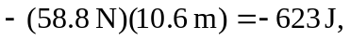 so the total work done by friction is 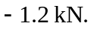 b) 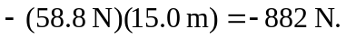
c)
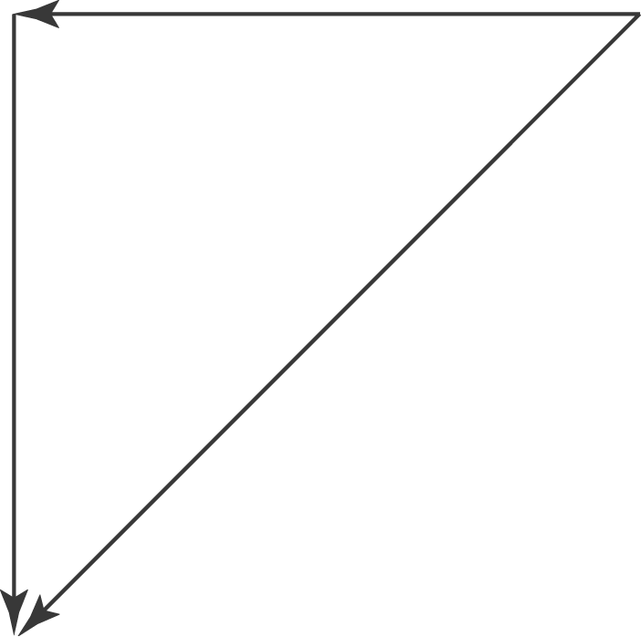

The net work done by friction depends on the path, so friction is not a conservative force.

